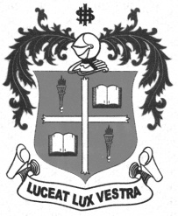
LOYOLA COLLEGE (AUTONOMOUS), CHENNAI – 600 034
M.A. DEGREE EXAMINATION - APPLIED HISTORY
FIRST SEMESTER – APRIL 2012

HT 1807 - HISTORY OF MODERN ASIA

Date : 27-04-2012 Dept. No. Max. : 100 Marks

Time : 9:00 - 12:00
PART – A

Answer any Four of the following in about 100 words each: (4 x 5 = 20 Marks)
- Anti-Fascist People’s Freedom League
- Chiang- Kai -Sheik
- Geneva Agreement.
- Katipunam
- Khemer Rouge
- Zionism

PART – B

Answer any Two of the following in about 200 words: (2 x 10 = 20 Marks)
- Examine the causes for nationalism in Indo-China and narrate its impact.
- Assess the role of Ho’ Chi-minh in the National Movement of Vietnam.
- Examine the economic progress of Japan since World War II.
- Write a brief note on Korean Crisis.

PART – C

Answer any Three of the following in about 1200 words: (3 x 20 = 60 Marks)

- Critically analyse the contemporary problems and challenges of Asian countries.
- Evaluate the various stages of Burmese National Movement.
- Estimate the Career and Achievements of Mao-Tse-Tung.
- Examine the causes and results of Arab-Israeli war.
- Discuss the Problems and Disputes between Iran and Iraq.

************

